Project Proposal: Car Workshop Management System

Submitted By : Hamdan Yasir & Hudaibia Rehman

Submitted To : Sir Ali Hassan

Subject : Database Management System (Lab)

Class & Section : BSSE GROUP A

Semester : IV

Milestones
- ERD Diagram | V1.0
 | V1.1

ERD (Entity Relationship Diagram)

🔹 Main Entities & Relationships
- Customer → Vehicle (1:M)
- Vehicle → ServiceJob (1:M)
- Mechanic → ServiceJob (1:M)
- ServiceJob → Invoice (1:1)
- ServiceJob ↔ SparePart (M:N via ServiceParts)

- ERD DIAGRAM:
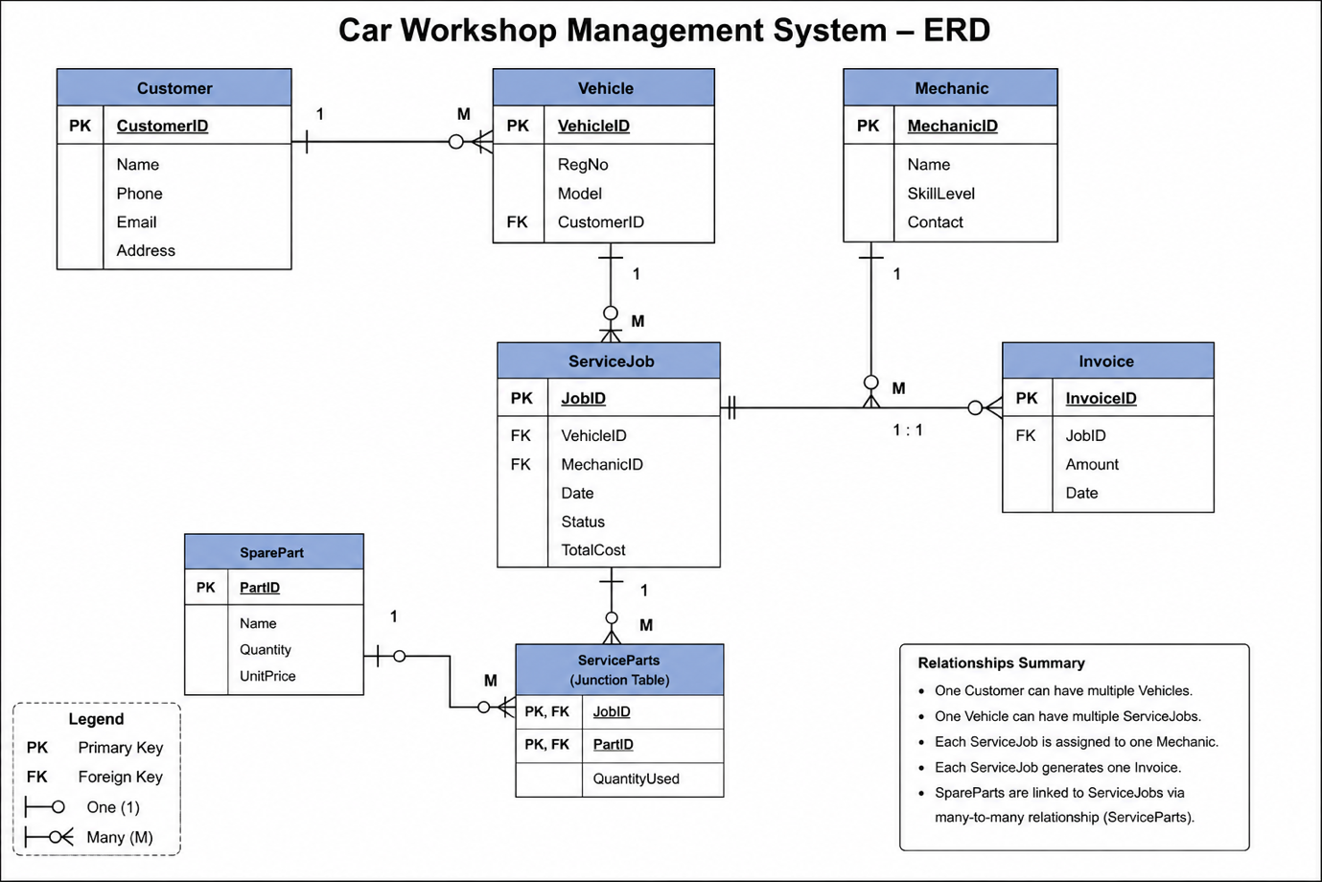

Entities with Attributes
Customer
- CustomerID (PK)
- Name
- Phone
- Email
- Address
Vehicle
- VehicleID (PK)
- RegNo
- Model
- CustomerID (FK)
Mechanic
- MechanicID (PK)
- Name
- SkillLevel
- Contact
ServiceJob
- JobID (PK)
- VehicleID (FK)
- MechanicID (FK)
- Date
- Status
- TotalCost
SparePart
- PartID (PK)
- Name
- Quantity
- UnitPrice
Invoice
- InvoiceID (PK)
- JobID (FK)
- Amount
- Date
ServiceParts (Junction Table)
- JobID (FK)
- PartID (FK)
- QuantityUsed

Keys & Relationships Explanation
- Primary Keys (PK): Unique identifiers (CustomerID, VehicleID, etc.)
- Foreign Keys (FK): Can be multiple.
  - Vehicle.CustomerID → Customer.CustomerID
  - ServiceJob.VehicleID → Vehicle.VehicleID
  - ServiceJob.MechanicID → Mechanic.MechanicID
  - Invoice.JobID → ServiceJob.JobID
  - ServiceParts.JobID → ServiceJob.JobID
  - ServiceParts.PartID → SparePart.PartID

